

**UNIVERSITY OF RWANDA**

**COLLEGE OF SCIENCE AND TECHNOLOGY**

**SCHOOL OF INFORMATION COMMUNICATION TECHNOLOGY**

**DEPARTMENT OF COMPUTER AND SOFTWARE ENGINEERING**

**PROJECT REPORT ON**

**“INTELLIGENT TRAFFIC LIGHTS FOR VISUALLY IMPAIRED PEOPLE”**

Submitted By

**Shema Lucien 218000277**

**Mukundiyukuri Didace 218005617**

**Ishimwe Marie Claire 217205798**

Under The Guidance of:

**Dr Alexander Ngenzi**

Submitted in Partial fulfillment of the requirements for the award of

**BACHELOR OF SCIENCE DEGREE IN COMPUTER ENGINEERING**

**January 6th, 2021**

**PROJECT ID: CSE/FTY4/21/11**

# 

**Kigali, January, 2022**

**UNIVERSITY OF RWANDA**

**COLLEGE OF SCIENCE AND TECHNOLOGY**

**AVENUE DE L'ARMEE, B.P. 3900 KIGALI, RWANDA**



**SCHOOL OF ICT**

**DEPARTMENT OF COMPUTER AND SOFTWARE ENGINEERING**

**C E R T I F I CAT E**

This is to certify that the Project Work entitled “**INTELLIGENT TRAFFIC LIGHTS FOR VISUALLY IMPAIRED PEOPLE”** is a record of the original bonafide work done by:

Shema Lucien 218000277

Mukundiyukuri Didace 218005617

Ishimwe Marie Claire 217205798

Impartial fulfillment of the requirement for the award of Bachelor of Science Degree in Computer Engineering of College of Science, Technology, University of Rwanda during the Academic Year 2020/2021.

……………………… ……………………………

**Dr Ngenzi Alexander Mr. MURANGIRA Theoneste**

Supervisor Head of Dept. of CSE

Name and Signature Name and Signature

Submitted for the Project Examination held at CST on ………………………………...

# DECLARATION

We Lucien SHEMA, Didace MUKUNDIYUKURI, and Marie Claire ISHIMWE hereby declare to the best of our knowledge that this work is original and has never been presented or submitted elsewhere, for any academic award in any University or institution of higher learning for the award of any degree. We therefore declare that; this work is our own contribution for the partial fulfillment of the award of the degree of Bachelor of Computer Engineering.

Declared:

...................................

Mr. Lucien SHEMA

Reg.No: 218000277

............................................

Mr. Didace MUKUNDIYUKURI

Reg.No: 218005617

.............................................

Ms. Marie Claire ISHIMWE

Reg.No: 217205798

# DEDICATION

We dedicated this book:

▪ To The Almighty God

▪ To Our Parents and Family Members

▪ To Classmates and Friends

▪ To all Teachers and Lecturers

# ACKNOWLEDGEMENT

We thank Almighty God for the gift of life and spirit of hard work that he has given to us especially during this project. We feel thankful to CST for its contribution for carrying out our studies. We are grateful for members of our family and our relatives; we sincerely thank Dr Alexander Ngenzi, our guider in this project, for his constant support through the course and for providing necessary facilities to carry out this project.

# ABSTRACT

The system uses an open source Arduino Uno as a module to control the traffic lights and generates sounds when it is a turn of pedestrians to cross the road which will help a person who has eye disability. It will be designed using Microcontroller, LEDS, and Speaker. The commands are processed by Arduino Uno and the LEDS will be switched on (4-way roads, 1-way road, others) to allow cars to pass and generates the sound which will alert those people with disabilities to cross the road when needed. using Arduino libraries available in the Arduino library. The amplifier is used for amplification of the sound and The LEDS will be switched on to guide the people to cross the road. The output of amplifier will be provided to the speakers which give the output audible to human ears. The goal of this project is to help the persons with eye disabilities to know the right time to cross the road with the help of the sound because they do not have the ability to know the right time. The sound will be generated at the same time when the green light switched on which gives the pass to the pedestrians. This system will ease the use of the road, reduce time wasting and reduce accidents that can be caused by visually impaired People.

**Keywords:** Arduino Uno, Amplifier, Speaker, Resistor, LED (Light Emitting Diode).

**TABLE OF CONTENTS**

DECLARATION iii

DEDICATION iv

ACKNOWLEDGEMENT v

ABSTRACT vi

LIST OF ABBREVIATIONS x

CHAPTER 1 GENERAL INTRODUCTION 1

1.1 Introduction 1

1.2. Background 1

1.3. Problem statement 2

1.4. Objectives 2

1.4.1. General objectives 2

1.4.2. Specific objectives 2

1.5. Scope of the study 2

1.6. Motivation of this study 2

1.6.1. Personal interests 2

1.6.2. Public interest 2

1.7. System requirements 3

1.8. Software requirement 3

1.9. Summary of chapter 1 3

CHAPTER 2 LITERATURE REVIEW 4

2.1. Introduction 4

2.2. Related works 4

2.2.1 Traffic Lights in Rwanda 4

2.2.2 Smart Traffic Control System 4

2.2.3 Automatic Intelligent Traffic Control System 4

2.2.4 Smart Traffic Light for Better Transportation 5

2.3 Comparison between related works and intelligent traffic lights for visually impaired people 5

2.4. Terminologies 6

2.5. Technologies 6

2.5.1 Arduino Uno 6

2.5.2 Arduino Software 7

2.5.3 Arduino Integrated Development Environment 7

2.5.5 USB Cable 8

2.6. Proposed system 9

2.6.1 Advantages of Proposed System 10

2.6.2 Limitations of Proposed system 10

2.7 Gaps in existing system 10

2.8. Summary of chapter 2 11

CHAPTER 3 RESEARCH METHODOLOGY 12

3.1. Introduction 12

3.2. Data collection methods 12

3.2.1. Interview 12

3.2.2. Internet Search 12

3.2.3. Observation 12

3.3. Software development model 12

3.4. System requirements of proposed system 13

3.4.1. Hardware requirements 13

3.4.2. Software requirements 14

3.5. Functional requirements 14

3.6. Non- functional requirements 14

CHAPTER 4 DESIGN AND IMPLEMENTATION 15

4.1 Introduction 15

4.2 Design 15

4.2.1 Uml Diagrams 15

4.2.1.1 Use case 15

4.2.1.2 Activity diagram 17

4.2.1.3 Circuit Diagram 17

4.3 Implementation 18

4.3.1 Hardware Installation 20

4.4 Result Analysis 22

4.4.1 Analyzed Scenario 22

4.5 Comparison Table between Proposed System and Existing System 25

CHAPTER 5 CONCLUSION AND RECOMMENDATIONS 28

5.1 Conclusion 28

5.2 Recommendation and future work 28

REFERENCES 29

# List of abbreviations

**CPU**: Central Processing Unit

**CST**: College of Science and Technology

**IDE**: Integrated Development Environment

**LED**: Light Emitting Diode

**PC**: Personal Computer

**RAM**: Random Access Memory

**UR**: University of Rwanda

**WHO**: World Health Organization

**LIST OF FIGURES**

**Figure 2.1:** Example of embedded System 6

**Figure 2.2:** Front of the Arduino Uno Board 7

**Figure 2.3:** The Arduino IDE 8

**Figure 2.4:** The Arduino USB cable 8

**Figure 2.5:** Block Diagram 10

**Figure 3.1** Waterfall Model 13

**Figure 4.1:** Use case diagram 16

**Figure 4.2:** Activity diagram 17

**Figure 4.4:** Circuit Diagram 18

**Figure 4.6:** Hardware part 21

**Figure 4.7:** 4 Way intersection 23

**Figure 4.8:** Vehicles graph 24

**Figure 4.8:** Pedestrians graph 25

**LIST OF TABLES**

**Table 1** Vehicle percentage in the various Lanes 23

**Table 2** Pedestrian percentage in the various Lanes 24

**Table 3** Result Analysis 26

# CHAPTER 1 GENERAL INTRODUCTION

## 1.1 Introduction

This project is based on Intelligent Traffic Lights for Visually impaired People which can be used by pedestrian’s specifically visually impaired People to cross the road. The system will give the alert by using the sound to the pedestrians wanting to cross the road when it is their turn, otherwise the sound will be off. The system will block the cars by switching on the red light, and switches on the green light on the pedestrians’ side at the same time provide sound which will help those who has blindness to know the right time to cross the road.

## 1.2. Background

According to the latest WHO data published in 2018 Road Traffic Accidents Deaths in Rwanda reached 4,054 or 7.14% of total deaths. The age adjusted Death Rate is 45.90 per 100,000 of population ranks Rwanda #7 in the world. Road accidents are ranked number 5 among the causes of deaths [1].

The good news is that traffic lights, which have come a long way since their birth, are about to avoid these kinds of situations. Traffic light system is a system came to save people’s lives when they are crossing the road.it installed in zebra crossing for guiding cars and pedestrians to know the right time to cross the road.

Before the traffic light installation in, it was up to traffic police to direct and control transportation flow. They had to be mindful of carriages, cars, and pedestrians, giving each group clear instructions on how and when to proceed.

Nowadays, of course, using law enforcement officers for traffic duty is an emergency tactic. We only use these officials when a traffic light loses electricity, or the power grid is down.

In Rwanda, technology to monitor and prevent road accidents is developing. Mostly, setting road camera, Traffic Lights and speed-governor devices in passenger cars reduce the frequency of road accidents. However, no appropriate technological approach exists when the pedestrian especially blind people want to cross the road [13].

In this project, we will be discussing what to do in helping people have eyes disability to know the right time to cross the road. So, it is why we came up with this great, cheap, easy to use system. Where pedestrians who are visually impaired are able to cross the road in right time with sound guidance.

## 1.3. Problem statement

In Rwanda, lives of pedestrians who are visually impaired are under risk because no advanced technological approach that may guide them when they are crossing the road when needed.

The current road set up at the zebra crossing makes pedestrian specifically visually impaired people traffic susceptible to road accidents or injuries especially during morning, lunch and evening hours when both traffic levels are relatively high. The system is highly favoring vehicular traffic leaving pedestrian traffic slightly vulnerable when they wish to cross the road to get to the other side of the road. Pedestrians have to wait for some time for vehicular traffic to clear up at times endangering themselves by making miscalculated moves while crossing the road. This is due to the fact that there is no appropriate crossing facility to cater for them. Visually impaired people are legitimate users of the transportation system and they also require safe crossing facilities.

## 1.4. Objectives

### 1.4.1. General objectives

The general objective of this project is to Design Intelligent Traffic Lights for Visually Impaired People.

### 1.4.2. Specific objectives

The specific objectives of this project are:

* To Analyze and improve the existing Traffic Light System
* To design intelligent Traffic Lights for visually impaired people
* To implement the system using Arduino Uno, Amplifier, Speakers

## 1.5. Scope of the study

The System will be accessible in Kigali. It will be used by visually impaired people and anyone who wish to cross the road.

## 1.6. Motivation of this study

### 1.6.1. Personal interests

* To improve our knowledge in programming
* To have confidence of competing with others
* To put in practice what we have learnt from University of Rwanda College of Science and Technology.
* The successfully implementation of this project will allow us to gain experiences in the applicable technologies as well as getting our degrees.

### 1.6.2. Public interest

* To create Intelligent Traffic Lights for Visually impaired People
* To save people’s lives
* To Reduce time wasting

## 1.7. System requirements

To design and implement Intelligent Traffic Lights with for visually impaired People, the required devices are:

* Arduino Uno
* Laptop with RAM:8.00GB, Processor: Intel(R) Core(TM) i5-4300U CPU @ 1.90GHz 2.50 GHz
* Amplifier ,Speakers
* LED (Light Emitting Diode)
* Resistors, Wires ,Bread Board
* Battery

## 1.8. Software requirement

For the development of this project, the following software requirements will be considered.

* Arduino IDE
* Window Operating System

## 1.9. Summary of chapter 1

As a conclusion, the first chapter is dealing with the general background, scope and objective of the project.

# CHAPTER 2 LITERATURE REVIEW

## 2.1. Introduction

This chapter presents the definitions, concepts and critics on related topics to this project by comparing research question and result attended. First, it gives some concepts that have been used in the implementation of this work especially the target of avoiding death of peoples. Secondary it makes a comparative study on different reviews written to the related topic.

## 2.2. Related works

### 2.2.1 Traffic Lights in Rwanda

The traffic light is an important guarantee for maintaining traffic order and ensuring the traffic is safe and unimpeded. In our daily life, when we pass an intersection, where the system using an LED such red, green and yellow which give the permission to pedestrians so that we can cross the roads. The traffic light in Rwanda uses LEDs to control the traffic by giving turns to the road for proper management and accident reduction

### 2.2.2 Smart Traffic Control System

To make this traffic light controlling more efficient we exploit the emergence of new technique called as “Smart Traffic Control System”. This makes use of sensors along with embedded technology. The timings of the red and green lights will be smartly decided based on the traffic on adjacent roads. As compared to fixed mode traffic light controller this new system is more efficient and flexible. It also has an intelligent traffic control system to pass the emergency vehicles such as ambulance, fire brigade etc. and also detects and track the stolen vehicles. The design also has scope for further expansion [2].

### 2.2.3 Automatic Intelligent Traffic Control System

Vehicle travel across the world is increasing, especially in the larger urban areas. Therefore, to better accommodate this increasing demand, the traffic control algorithm needs to be simulated and optimized. This project offers the idea of traffic light control using wireless sensor network.

It is a serious problem in the traffic congestion in many major cities around the world and in these cities, it has become a nightmare for travelers. Traditional systems do not control variable flows coming near junctions. In addition, interconnection between adjacent traffic light systems is not implemented in the current traffic system of passage of vehicles, passage of emergency vehicles, and passage of pedestrians [3].

### 2.2.4 Smart Traffic Light for Better Transportation

Traffic lights currently applied are not considered optimal traffic congestion problem because the system applied to traffic light only refers to the time while the density level at the crossroads is not always the same. Then the congestion level at the crossroads can’t be controlled properly. Therefore, we need a Smart Traffic Light system that is able to optimize the time of change of traffic light based on the length of the queue in real time [4].

**2.2.5 Real-Time Detection of Pedestrian Traffic Lights for Visually-Impaired People**

To help the visually impaired people brought a solution for the detection of pedestrian traffic lights together with their current state for helping visually-impaired people to cross the streets with the aid of their mobile devices. For such, we provide a novel public dataset with 4,399 labeled images of pedestrian traffic lights and we present a detailed comparison among the state-of-the-art methods for classification and localization/detection [31].

**2.2.6 Traffic Light Pilot for Visually Impaired People**

The way to help the visually impaired people in order to cross the roads might deploy the Android app for the recognition of red and green color using a smartphone. This idea to develop an app that was built using the camera and other sensors (e.g. GPS, Compass) of a smartphone to detect the red and green phases of a pedestrian light and translating them to acoustic or tactile signals. This app aims to allow people with a visual impairment to safely cross a street at a pedestrian crossing [32].

## 2.3 Comparison between related works and intelligent traffic lights for visually impaired people

It is nearly impossible to fully prevent road accidents 100%, Although the Safe system and traffic lights have come with a nice approach of reducing the number of deaths could arise in road accidents, design of intelligent traffic lights for visually impaired people will come into use where people with eye disability. The design of intelligent traffic lights for Visually Impaired People should be a project concerning the area of cooperating embedded systems [5].In Rwanda to cross the road to those persons who have eye disability is still a serious issue even in less developed countries. The way of helping those peoples to cross the road without an person to guide her/him is still a problem but our project is there to solve this problem, where we will design intelligent traffic lights for Visually Impaired People to help those persons who have eye disability to know the real time to cross the road, our project will reduce to wasting time during to cross a road and minimize the death which are occurring in zebra cross for visually impaired people [6].

## 2.4. Terminologies

Embedded Systems refers to the combination of computer hardware and software, fixed in capability or programmable, designed for a specific function or functions within a larger system. Industrial machines, agricultural and process industry devices, automobiles, medical equipment, cameras, household appliances, airplanes, vending machines and toys, as well as mobile devices, are possible locations for an embedded system.

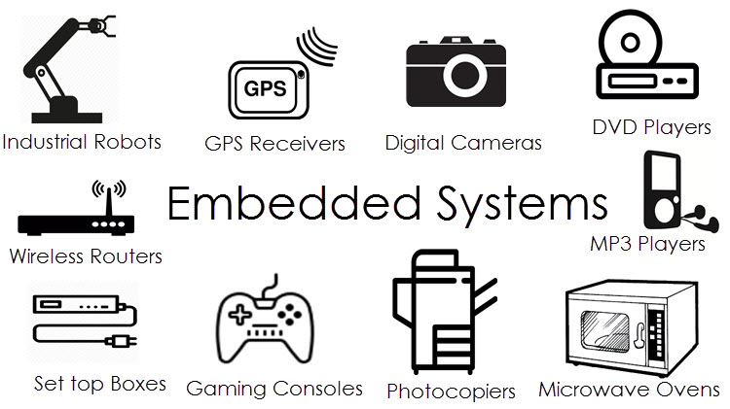

##### **Figure 2.1: Example of embedded System**

## 2.5. Technologies

### 2.5.1 Arduino Uno

It is an Arduino based board also known as a microcontroller, which is the same thing as a small computer on a single, integrated circuit with a processor, memory, and controllable output and input pins. On this board, one can write programs and create interface circuits to read switches, sensors, lights and to control motors as well as other electronic components with very little effort. It supports C and C++ programming languages [5].

Arduino is an Open Hardware project started in 2005 that tries to bring the world of digital electronics to education, research, and the maker community. Arduino Uno is Italian and means “one”. It was released publicly in September 25, 2010. It is inexpensive and reliable, $30 or €22. 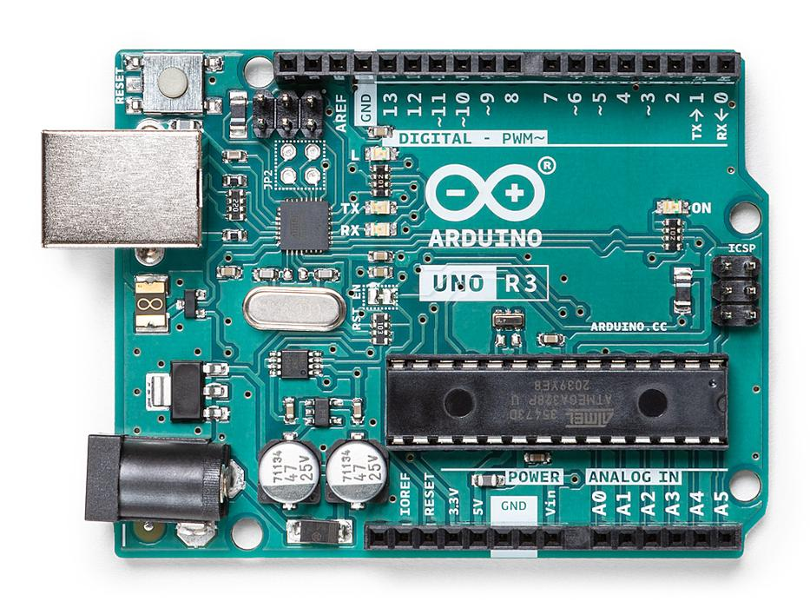

##### **Figure 2.2: Front of the Arduino Uno Board**

### 2.5.2 Arduino Software

It is a collection of instructions that tell the hardware what to do and how to do it. Two types of software are used:

* The integrated development environment (IDE).
* The Arduino sketch that one creates.

The IDE software is installed on the personal computer and is used to compose and send sketches to the Arduino Uno board.

### 2.5.3 Arduino Integrated Development Environment

The Arduino IDE resembles a simple word processor [6].it is divided different areas like:

• The sketch area: is an area which used to write the codes

• The text area: this is area where you can put your code.

• The text console area

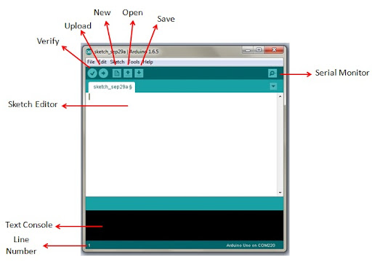

##### **Figure 2.3: The Arduino IDE**

### 2.5.5 USB Cable

The A to B USB cable is used for programming and providing power to the Arduino Uno. This type of USB cable is mostly used to connect printers to computers

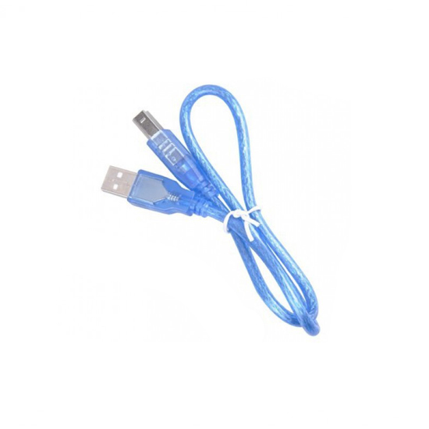

##### **Figure 2.4: The Arduino USB cable**

## 2.6. Proposed system

The proposed system helps visually impaired people to cross the road without requiring support from other persons .it provides the real time solution to the visually impaired people to know exactly time to cross the road and the reduce the death which are caused by crossing the road without knowing exactly the real time to pass, this system will use the amplifier, speaker and LEDs. The LEDs will be used to generate the lights which will control the traffic in the road and by using the amplifier and speaker the system will be able to produce audible sounds to the human ears and the visually impaired people will know the right time to cross the road.

The system will use the LEDs in one way the system generates the red color all pedestrians will stop and will wait 30 seconds because the cars will pass and also system will generate green color with the sound which help visually impaired person to cross the roads ,the cars will wait the 20 seconds so that the pedestrians will pass.

Our system will use the fourth way, firstly, the Lane 1 gets its Green light turned. Hence, in all the other Lanes, their corresponding Red lights are turned on. After a time, delay of predefined time says 5 seconds, the Green light in the Lane 3 must be turned on and the Green light in the Lane 1 must be turned off.

As a warning indicator, the Yellow light in Lane 1 is tuned on indicating that the red light is about to light up. Similarly, the yellow light in the Lane 3 is also turned as an indication that the green light about to be turned on.

The yellow lights in Lanes 1 and 3 are turned for a small duration say 5 seconds after with the red light in the Lane 1 is turned on and green light in Lane 3 is also turned on.

The green light in Lane 3 is also turned on for a predefined time and the process moves forward to Lane 4 and finally Lane 2.

Furthermore, the time which visually impaired people wait to cross the road will be reduced also the person who will guide that visually impaired person will not be necessary.

The prototype consists of three main building blocks:

• A set of traffic lights – to control vehicular traffic flow.

• A set of pedestrian lights – to control pedestrians.

• A pair of Speakers – to alert the pedestrians to cross the road.

The traffic lights, pedestrian lights and speakers are all connected to an Arduino

Uno microcontroller. Figure 2.5 below is the system block diagram.

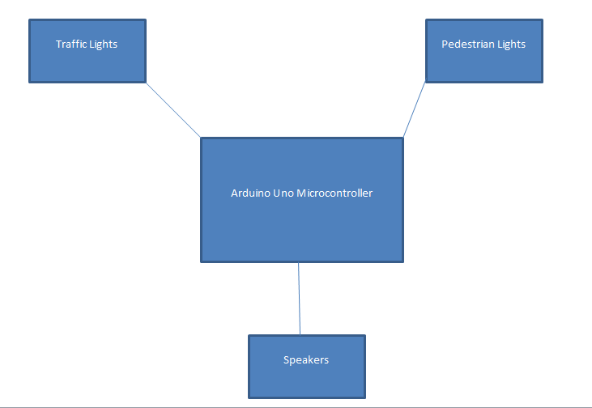

##### **Figure 2.5: Block Diagram**

### 2.6.1 Advantages of Proposed System

* It helps visually impaired people to cross the road using sound without the support of other persons.
* It helps people who do not have knowledge of traffic rules (people from rural areas)
* It helps to reduce the time loss for visually impaired people and other people using the road.
* It helps to save people’s lives

### 2.6.2 Limitations of Proposed system

* In case of power loss and speaker failure there is a need of man power to help the pedestrians and drivers.

## 2.7 Gaps in existing system

* In existing system there in no technological approach that can help visually impaired people to walk and cross the road safely.
* Time wasting due to the safety of pedestrians who spent much time crossing the road.

## 2.8. Summary of chapter 2

Finally, the technology develops with the new car may introduced, the traffic lights increase day per day. This chapter presented to you a summary about previous findings existing system status and proposed system design intelligent Traffic Lights for Visually impaired People helping those persons to cross the road and reduce death which occur in zebra crossing.

# CHAPTER 3 RESEARCH METHODOLOGY

## 3.1. Introduction

This chapter contains different methods used for analyzing and collecting data. The software development model covers all about the techniques and system tools to use in order to Design and implement Intelligent Traffic Lights for Visually Impaired People.

## 3.2. Data collection methods

Data collection methods involve techniques that were used to collect data in this project, such as:

* Observation
* Interview
* Internet search

### 3.2.1. Interview

Interview is a research methodology used in order to acquire all information through discussions with different people at the sites. In this method consisted of asking guided questions to pedestrians, and other people who use the roads mostly in cities. Answers from them, brought trustful data.

### 3.2.2. Internet Search

In this research, we visited different web sites to look more information about how to implement and reduce number of people who lost their lives in road accidents.

### 3.2.3. Observation

Observation made in the roads of Kigali shows that there is a large number of people who can face road accident when they are crossing the road. The drivers who lost the time waiting for those people who have eye disabilities to cross.

## 3.3. Software development model

During the development of this system, Waterfall Model was implemented. This model is a Sequential design process, used in software development process, in which progress is seen as following steadily downwards [7]. Those phases include the following:

* Requirement
* Design
* Implementation
* Testing
* Maintenance

**Definitions**

Requirement: here data have been collected and then the information gotten were analyzed to help in design and implementation of this system.

Design: This phase focus on what this system should perform, this involves architecture design.

Implementation: This phase focuses on coding, and consists of coding and testing subcomponents of the system referring to the system design from the system requirements.

Testing and Maintenance: This is the final stage of our application. The system will be tested to make confirmation that it meets with system requirements [8].

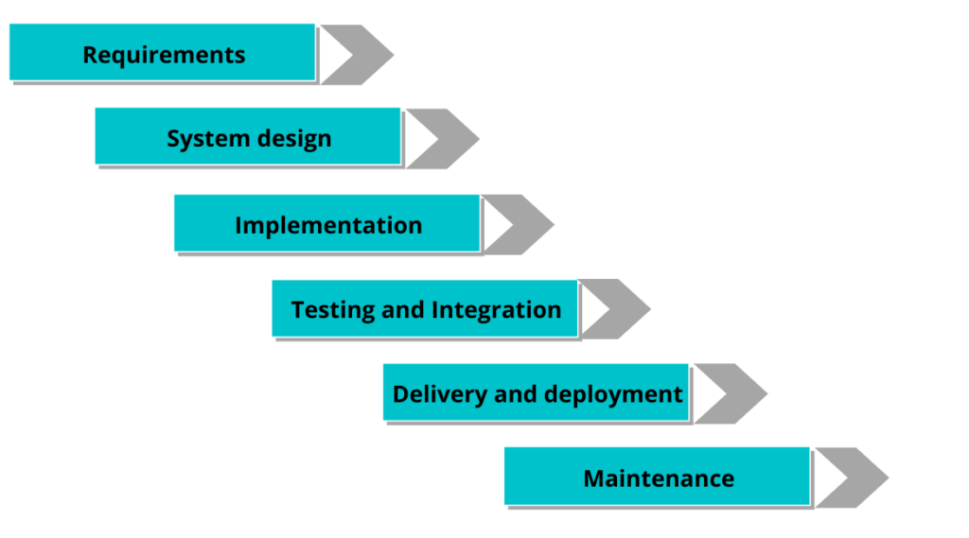

##### **Figure 3.1 Waterfall Model**

We used the waterfall model because it divides the process into a set of phases. This model considers that one phase can be started after completion of the previous phase. That is the output of one phase will be the input to the next phase. means, after gathering requirements and designing the system. The system will be simulated before assembling hardwares.Thus the development process can be considered as a sequential flow in the waterfall. Here the phases do not overlap with each other.

## 3.4. System requirements of proposed system

System requirements are categorized into two classes: Hardware and Software requirements.

### 3.4.1. Hardware requirements

This project requires the following hardware requirements:

* Arduino Uno
* Laptop with RAM:8.00GB, Processor: Intel(R) Core(TM) i5-4300U CPU @ 1.90GHz 2.50 GHz
* Amplifier ,Speakers
* LED (Light Emitting Diode)
* Resistors, Wires, Bread Board
* Battery

### 3.4.2. Software requirements

This project requires the following Software requirements:

* Embedded programming
* Windows 10 Operating system

## 3.5. Functional requirements

The functional requirements are about what the system is supposed to do often refer to its Functionality [9]. For this system they are:

* To provide the sound to the pedestrians
* To switch on the traffic lights to allow the pedestrians to pass and to stop the cars

## 3.6. Non- functional requirements

Describe the general properties of a system. They are also known as quality attributes [10].

* Usability: The user is able to use the application without any problem
* System will be available 24 hours a day
* Reliability
* Maintainability

# CHAPTER 4 DESIGN AND IMPLEMENTATION

## 4.1 Introduction

This Section describes the implementation details of an IoT Driven Emergency Response System to enhance the existing Emergency Medical Services. It shows design with aid of different diagrams that include Use Case Diagram, Sequence Diagram, Activity Diagram, circuit diagram and the results of those design diagrams after converting them into the language a computer can understand.

## 4.2 Design

### 4.2.1 Uml Diagrams

UML (Unified Modeling Language) is a standard language for system design and analyze for what the system will do, who will do it, how they will be done and the sequence of how activities will follow each other until the system’s objective is achieved.

#### 4.2.1.1 Use case

This diagram presents a graphical overview of the functionality provided by a system in terms of actors, their goals, and any dependencies between use cases, then user interaction to the system.

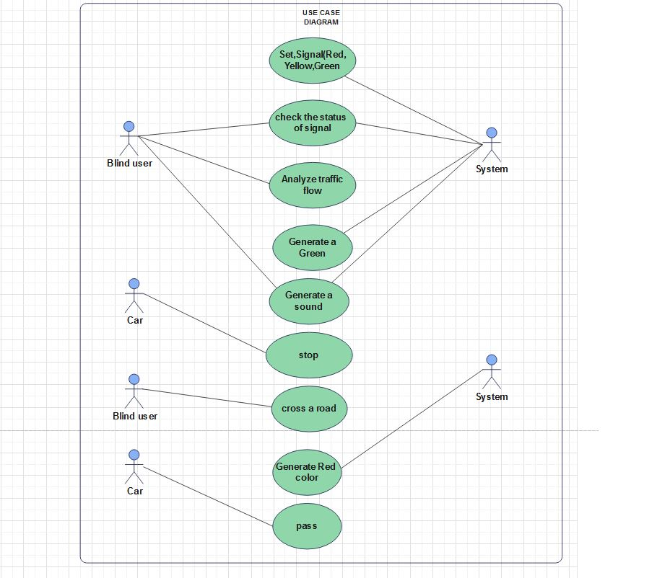

##### **Figure 4.1: Use case diagram**

#### 4.2.1.2 Activity diagram

Activity Diagram is a UML diagram that shows the decomposition of system activities into its constituents, it is another important diagram that describes the dynamic aspects of the system[25], it is similar to a flowchart but in addition it represents the flow from one activity to another, where activity is defined as an operation of the system.

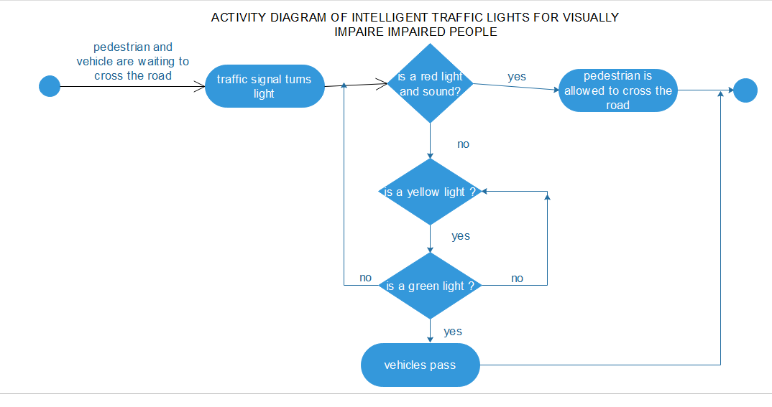

**Figure 4.2: Activity diagram**

#### 4.2.1.3 Circuit Diagram

Since the project is a traffic light controller, the circuit consists of many LEDs (20 as a matter of fact) as we are implementing traffic lights at a 4 way intersection. The project is a simple representation of traffic light controller and hence no other extra components are used.

We need three LEDs of Red, Yellow and Green colors at each intersection. The intersection is divided in to four lanes: Lane1, Lane 2 Lane 3 and Lane 4.

All the LEDs are connected to the Arduino UNO’s digital I/O pins through respective current limiting resistors of 1KΩ.

All the connections are made as per the circuit diagram. The complete wiring diagram of the circuit is shown below.

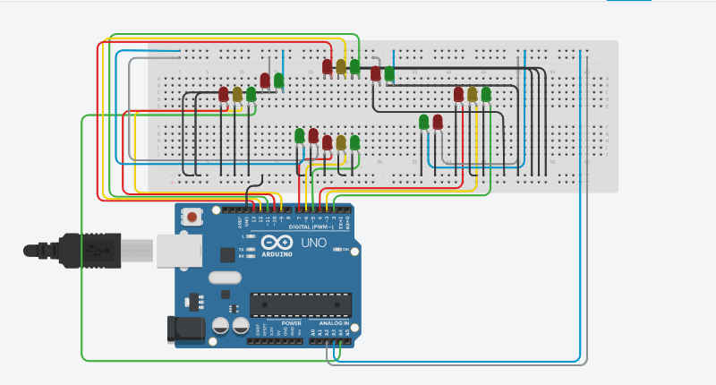

##### **Figure 4.4: Circuit Diagram**

**Note:** In the practical implementation of the project, we did not use the current limiting resistors as the current from each digital I/O pin of the Arduino UNO is only 20mA. This small current will not burn the LED. But it is advised to use the current limiting resistors of at least 220 Ω in series with each LED.

Also note that Arduino UNO in this project acts as source of current for all the LED i.e. it provides the necessary current to turn ON the LED. Hence, a reliable power supply (like a DC adapter) to power the Arduino UNO must be used.

## 4.3 Implementation

The real time traffic light controller is a complex piece of equipment which consists of power cabinet, main controller or processor, relays, control panel with switches or keys, communication ports etc.

In this project, a simple traffic light system for a 4 way intersection is implemented using Arduino UNO. Although it is not the ideal implementation for real life scenarios, it gives an idea of the process behind the traffic light control system

The aim of the project is to implement a simple traffic light controller using Arduino UNO, where the traffic is controlled in a pre-defined timing system. The working of the project is very simple and is explained below.

Consider the following gif image showing a loop of traffic light operations. The project is also implemented in the same manner.

Proposed system is using Microcontroller, LEDS, and Speaker. The commands are processed by Arduino Uno and the LEDS will be switched on (4 way roads) to allow cars to pass and generates the sound which will alert visually impaired people to cross the road, if the red color is generated all car will be blocked and the side of pedestrians will generate the green color with the sound.

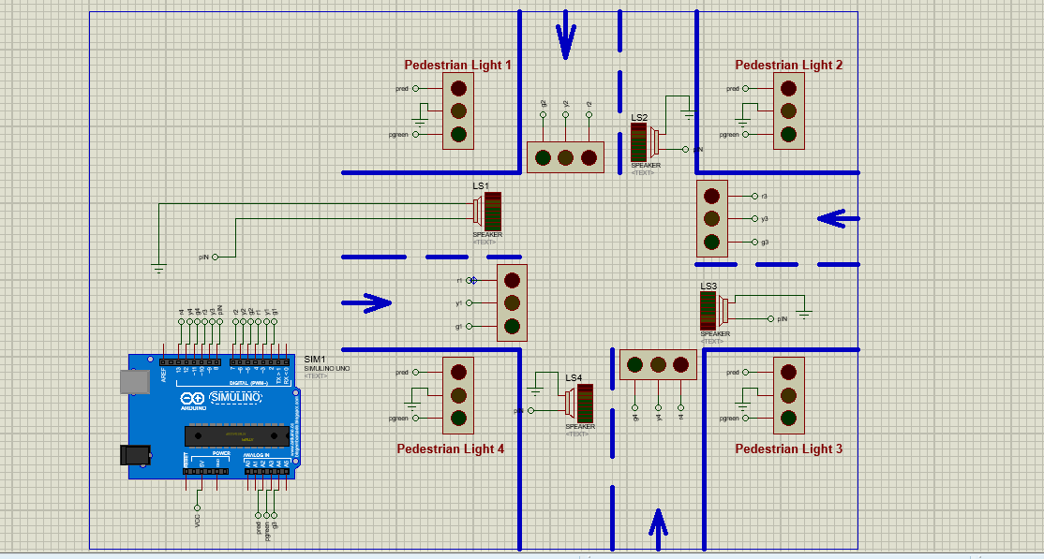

**Figure 4.5: 4-way traffic light with pedestrian**

In that, first the Lane 1 gets its Green light turned. Hence, in all the other Lanes, their corresponding Red lights are turned on. After a time delay of predefined time say 5 seconds, the Green light in the Lane 3 must be turned on and the Green light in the Lane 1 must be turned off.

As a warning indicator, the Yellow light in Lane 1 is tuned on indicating that the red light is about to light up. Similarly, the yellow light in the Lane 3 is also turned as an indication that the green light about to be turned on.

The yellow lights in Lanes 1 and 3 are turned for a small duration say 2 seconds after with the red light in the Lane 1 is turned on and green light in Lane 3 is also turned on.

The green light in Lane 3 is also turned on for a predefined time and the process moves forward to Lane 4 and finally Lane 2.

The system then loops back to Lane 1 where the process mentioned above will be repeated all over again.

### 4.3.1 Hardware Installation

This Picture shows the hardware connection of our Project. At start, green light of signal 1 and red lights at other signals will light up to give time to the vehicles at signal 1 to pass.

After 5 seconds, the yellow light at signal 1 will light up to give an indication that the red light at signal 1 is about to come up and also to give an indication to the vehicles at signal 2 that the green light is about to light up.

So after 2 seconds, red light at signal 1 will come up and green light at signal will come up meaning vehicles at signal 1 must stop and vehicles at signal 2 can move.

Similarly the traffic light controller will work for the signal 3, signal 4 and the system will keep looping.

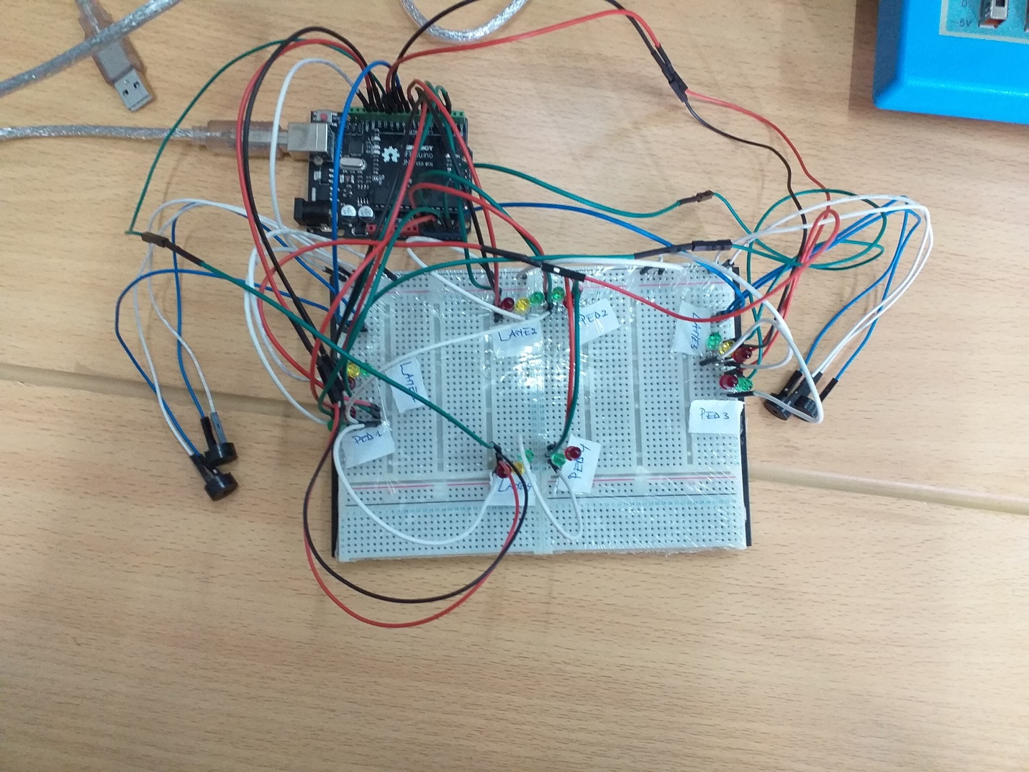

##### **Figure 4.6: Hardware part**

## 4.4 Result Analysis

In Rwanda, lives of pedestrians who are visually impaired are under risk because no advanced technological approach that may guide them when they are crossing the road when needed.

The current road set up at the zebra crossing makes pedestrian specifically visually impaired people traffic susceptible to road accidents or injuries especially during morning, lunch and evening hours when both traffic levels are relatively high. The system is highly favoring vehicular traffic leaving pedestrian traffic slightly vulnerable when they wish to cross the road to get to the other side of the road. Pedestrians have to wait for some time for vehicular traffic to clear up at times endangering themselves by making miscalculated moves while crossing the road. This is due to the fact that there is no appropriate crossing facility to cater for them. Visually impaired people are legitimate users of the transportation system and they also require safe crossing facilities.

The proposed system helps visually impaired people to cross the road without requiring support from other persons .It provides the real time solution to the visually impaired people to know exactly time to cross the road and the reduce the death which are caused by crossing the road without knowing exactly the real time to pass, this system will use the amplifier, speaker and LEDs. The LEDs will be used to generate the lights which will control the traffic in the road and by using the amplifier and speaker the system will be able to produce audible sounds to the human ears and the visually impaired people will know the right time to cross the road.

### 4.4.1 Analyzed Scenario

The proposed smart solution is applied on a signalized road intersection located in the urban area with 4 way intersection.

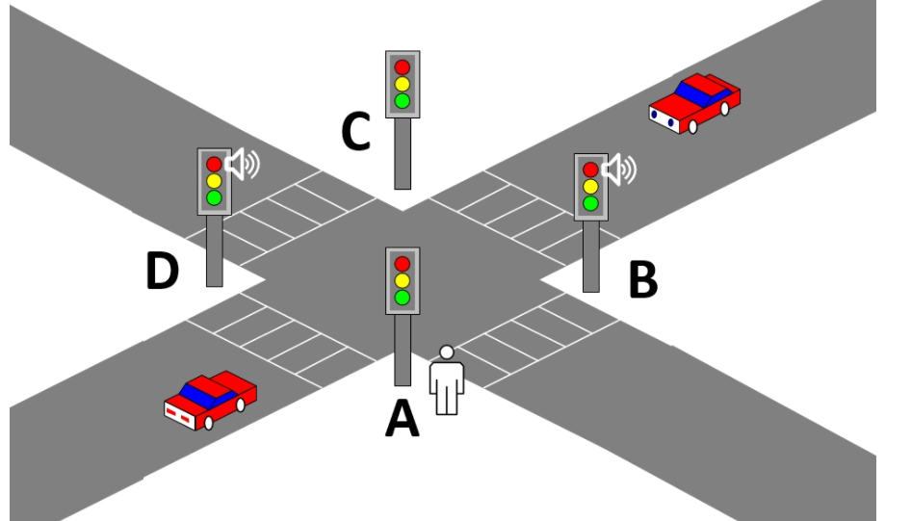

##### **Figure 4.7: 4 Way intersection**

**Table 1 Vehicle percentage in the various Lanes**

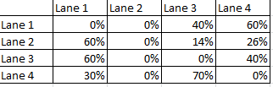

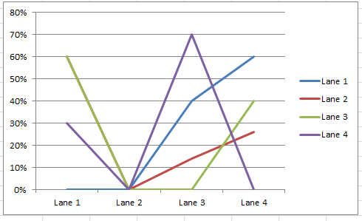

##### **Figure 4.8: Vehicles graph**

Figure

**Table 2 Pedestrian percentage in the various Lanes**

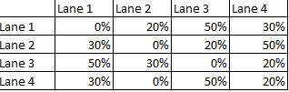

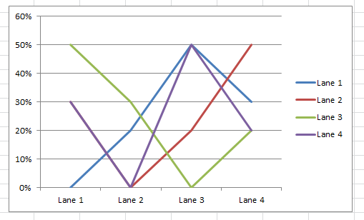

##### **Figure 4.8: Pedestrians graph**

The variability of vehicle and pedestrian flows is related to the activities that take place in the areas around the traffic light junction throughout the day. This variability is most noticed during the weekend. Therefore, to optimize the management of pedestrian/vehicle flows, the traffic light junction requires the implementation of a dynamic control infrastructure that can optimally handle the times of the traffic lights taking into account the number of pedestrians that are going to cross the road. Another peculiarity to consider is the time of day. In fact, as mentioned earlier, in some hours of the day, there may be copious flows of pedestrians and vehicles, while in others, the size decreases considerably. Consequently, the dynamic monitoring infrastructure of the traffic light cycle must also take into account whether it is at a critical time when evaluating the number of pedestrians and vehicles. The goal is to allow not only a modulation of flows consistent with the analyzed context, but also an increment of safety for pedestrians and motorists.

## 4.5 Comparison Table between Proposed System and Existing System

**Definitions**

**Accuracy** is the ability of the system to produce accurate results (and to what level of accuracy this is required).

**Efficiency** is measured in terms of time required to complete any task given to the system

**Availability** is the proportion of time that the system is functional and working.

**Reliability** is measured in terms of working of the project under different working environments and different conditions

**Performance** is the responsiveness of a system to execute a required action with a set time frame.

In our project we used accuracy, efficiency, availability, reliability and performance which helped us to compare our project with the existing systems. After comparing them we improved our project based on these parameters as explained in the table below.

**Table 3 Result Analysis**

|  |  |  |  |  |  |  |
| --- | --- | --- | --- | --- | --- | --- |
|  | **Traffic Lights in Rwanda** | **Smart Traffic Control System** | **Automatic Intelligent Traffic Control System** | **Real-Time Detection of Pedestrian Traffic Lights for Visually-Impaired People** | **Traffic Light Pilot for Visually Impaired People** | **Intelligent Traffic Light for Visually Impaired People** |
| Accuracy | This system is more accurate | System use sensors less accuracy | System uses wireless sensor network is less accuracy | System use mobile devices is less accuracy | Using the camera and sensors | System will Uses LEDs and speakers are accurate system for visually impaired people |
| Efficiency | Control the traffic using programmable turns. | Control the  Traffic using sensors and has intelligent traffic control system which allows pass of the emergency vehicles  And helps to detect stolen vehicles. | Control the  Traffic using sensors and has intelligent traffic control system which allows pass of the emergency vehicles. | To help Impaired people to cross the streets with the aid of their mobile devices. | Deploy the Android app for the recognition of red and green color using a smartphone help the impaired to cross the roads | Control the traffic using programmable turns and alerts the pedestrians to cross the road by using sound which passes through the speakers. |
| Availability | The system is available all time | If the sensors failed whole system will goes down | If the network will go the system will shut down | System will use mobile phone if telephone hasn’t power system won’t available | System won’t available | Our system will be available all the time to help visually impaired people  Availability will be 100% |
| Reliability | The system won’t help the visually impaired people | The system could not help pedestrians if the sensors will have any problems | The system has less reliable | Less reliable compare to the new system | System has moderate reliable | The system will continue to help the visually impaired people compare to the existing  Has reliable of 90% |
| Performance | low performance | Low performance | Moderate performance | Low performance | Medium performance | High performance  Of 90% |

Our project can have the positive impacts in the society where a simple traffic light controller is implemented in this project with a real chance of expansion. An external memory can be interface with the main controller so that the timings are not fixed during its programming but rather can be programmed during operation. Furthermore, an efficient traffic light controller system will include a pedestrian signaling system. System will provide the services to pedestrians without delay means is reactive system.

# CHAPTER 5 CONCLUSION AND RECOMMENDATIONS

## 5.1 Conclusion

The designing of a prototype for the automated traffic lights with pedestrian crossing control system was successful. The prototype worked perfectly using the concept of allocating pedestrians some crossing time without interference from vehicular traffic. The Speakers functioned perfectly displaying the alert message to the pedestrians.

Summing up, after gathering all requirements used for designing and developing our system, it was found that the application of our project will have a great impact in mitigating number of deaths and serious injuries of visually impaired people resulting from the wrong use of the road and violating traffic signs specifically traffic lights.

The system has the function of supporting visually impaired people to cross the road without need other people to help them. Not only that, this system will help those people to save time.

In our project, we didn’t achieve all functionality like to put button in system because of the limited time due to covid-19. In addition, we didn’t put sound which understand by everyone.

Not only those, we didn’t put the sensors in our project we recommend the future researcher will start with these issues.

This conclusion has been drawn after fully testing the system with its functionalities and found that it meets its specified objectives. As it can be able to alert the visually impaired people and control the cars traffic in a four-way road.

## 5.2 Recommendation and future work

Our project is not suitable for actual implementation but just a demonstration of the process behind the system. Real time traffic light controller systems are generally run time programmable i.e. the operator (usually a policeman) can change the timings of each lane as per the intensity of the traffic in each lane. There will also be a provision for either manual operation or pre-programmed operation. Also we faced the challenge of lacking the money to buy the advanced materials to use which are of high cost which we cannot afford as the students.

We recommend more technological researches to be conducted to enhance the facilities given to the Visually Impaired People to save their lives, we can’t fully prevent Road accidents but we can do the best possible to save the lives of People especially those who are visually Impaired.. In our project we covered, Controlling the traffic and pedestrian movements by giving them the right to pass in a given range of time. The pedestrians will hear the sound notifying them to pass. We used the alert, which we recommend the future researchers to replace it with the real sound of the person which can make it meaningful to all users. The future researcher who will have enough time they can add the sensors especially at the pedestrian side which can be used to detect if the person wants to cross the road so and gives the signal to the traffic lights and gives the permission to the pedestrians. We didn’t cover because of pandemic (covid-19). Furthermore, there can be the integration of push button which can also be used to request the permission of pedestrian to cross the road.

# REFERENCES

|  |  |
| --- | --- |
| [1] | worldlifeexpectancy, "www.worldlifeexpectancy.com," 2018. [Online]. Available: https://www.worldlifeexpectancy.com/rwanda-road-traffic-accidents. [Accessed 3 september 2021]. |
| [2] | internationaljournalssrg, "www.internationaljournalssrg.org," 2015. [Online]. Available: https://www.internationaljournalssrg.org/IJECE/2016/Volume3-Issue3/IJECE-V3I3P106. [Accessed 3 september 2021]. |
| [3] | irjet, "www.irjet.net," 2012. [Online]. Available: https://www.irjet.net/archives/V5/i3/IRJET-V5I356. [Accessed 3 september 2021]. |
| [4] | academia, "www.academia.edu," 2010. [Online]. Available: https://www.academia.edu/37015838/SMART_TRAFFIC_LIGHT_FOR_BETTER_TRANSPORTATION_IN_JAKARTA. [Accessed 2 september 2021]. |
| [5] | a. C. N. N. Kham, Implementation of modern traffic light control system, International journal of scientific and research publications, Vol. 4, Issue 6, Jun. 2014, 2014 jun 6. |
| [6] | W. H. M. a. D. H. P. C. Siswipraptini, Reducing a congestion with introduce the greedy algorithmon traffic light control, J. Phys. Conf. Ser, 2012. |
| [7] | hackerearth, "www.hackerearth.com," 21 October 2016. [Online]. Available: https://www.hackerearth.com/blog/developers/a-tour-of-the-arduino-uno-board/. [Accessed 3 september 2021]. |
| [8] | arduinotogo, "arduinotogo.com," 09 september 2019. [Online]. Available: https://arduinotogo.com/2016/09/09/chapter-3-parts-of-the-arduino-ide/. [Accessed 03 september 2021]. |
| [9] | blocshop, "www.blocshop.io," 10 may 2010. [Online]. Available: https://www.blocshop.io/blog/waterfallmodel. [Accessed 2 september 2021]. |
| [10] | blocshop, "www.blocshop.io," 20 april 2012. [Online]. Available: https://www.blocshop.io/blog/waterfall-advantages-disadvantages/. [Accessed 02 september 2021]. |
| [11] | altexsoft, "www.altexsoft.com," 23 july 2021. [Online]. Available: https://www.altexsoft.com/blog/business/functional-and-non-functional-requirements-specification-and-types/. [Accessed 03 september 2021]. |
| [12] | altexsoft, "www.altexsoft.com," 22 july 2021. [Online]. Available: https://www.altexsoft.com/blog/business/functional-and-non-functional-requirements-specification-and-types/. [Accessed 2 september 2021]. |
| [13] | W. H. M. a. D. H. P. C. Siswipraptini, “Reducing a congestion with introduce the greedy algorithmon traffic light control, J. Phys. Conf. Ser, 2012.  [14] F. H. Administration, "Part II of II: Best Practices Design Guide - Sidewalk2 -  Publications - Bicycle &amp; Pedestrian Program - Environment - FHWA," U.S.  Department of Transportation/Federal Highway Administration, 02 October 2014.  [Online]. Available:  http://www.fhwa.dot.gov/environment/bicycle_pedestrian/publications/sidewalk2/s  idewalks. [Accessed 04 April 2021].  [15] Federal Highway Administration, Manual on Uniform Traffic Control Devices for  Streets and Highways, United States of America: U.S.Department of Transportation,  2009.  [16] C. Zeeger, "Safety Effects of Marked Versus Unmarked Crosswalks at  Uncoontrolled Locations: Executive Summary and Recommended Guidelines,"  Federal Highway Administration, United States of America, 2002.  [17] Lincolnshire County Council, Pedestrian Crossings - A User's Guide, United  Kingdom: County Council Lincolnshire, 2009.  [18] M.Tauchi, M.Ohkura, T.Murakami, O.Shimizu. A consideration of tactile tiles and Audible  trafic signals installed in Japan. Proc. of International Mobility Conference (IMC 7), 206-209,  1994  [19]M. Tauchi, H. Sawai, J. Takato, T. Yoshiura, K. Takeuchi, Development and Evaluation of a  Novel type of Audible Traffic Signal for the Blind Pedestrians, Proceedings of International  Mobility Conference9, 1998 (in press)  [20] Technical Brochure No.26, Signal facilities for the blind study committee Report ,1975  [21] The report of National Police Agency, 1998  [22] T. Murakami, M. Ishikawa, M. Ohkura, H. Sawai, J.Takato, M. Tauchi ,­ Identification of  difficulties of the independent blind travelers to cross intersection with/without audible traffic  signals, Proceedings of International Mobility Conference9, 1998 (in press)  [23] T. Yoshiura, J. Takato, K. Takeuchi, H. Sawai, M. Tauchi. Development of a Novel Type of  Audible Traffic Signal for the Blind and Visually Impaired Pedestrians and Comparison of Its  Acoustic Guiding Function with the Presently Used Audible Traffic Signal. 4TH World  Congress on Intelligent Transprot Systems. 1-7(248PDF), 1997 |